**RCOMC Architectural Standards**  09/24/2023

**Standards for Front Entry Doors, Windows, Shutters & Patio Enclosures**

To help ensure personal safety, community aesthetics, code compliance, minimized potential for property damage and optimized insurance discounts, the River Club Board of Directors strives to provide a clear expectation for entry doors, windows, shutters and patios to our owners in common. The Board of Directors utilizes current information from the Miami-Dade County Building Codes as well as HVHZ impact rating wind mitigation requirements to optimize discounts on insurance rates for River Club.

Please follow the instructions below when renovating entry doors, windows, shutters and patio enclosures to meet our current standards. All of the said projects must receive written approval from the River Club Board of Directors prior to commencement of work. Application forms can be found on the River Club <http://rcmcowners.org> or in the office.

All unit exterior openings, i.e. entry doors, windows or patio enclosure projects must meet current Miami-Dade County Code, aka HVHZ or ASTM E1996 (Level D Impact Rating). With the exception of owner/builders with qualified exemptions and building permits, all work must be done by a contractor licensed and insured in the State of Florida and will require a building permit that your contractor will acquire on your behalf.

**PATIO ENCLOSURES:**

All patio enclosures must completely fill the exterior area, i.e., flush with the exterior wall, with screen or glass and must be bronze in color on the exterior and of aluminum construction. Plans submitted with the application must include a sketch with dimensions and the material specifications. Descriptions must include the wording “the construction will be in accordance with current Miami-Dade County Building Code, HVHZ or ASTM E1996 (Level D Impact Rating)” where applicable.

In lieu of HVHZ rated accordion shutters exterior to screen enclosures or ASTM E1996 (Level D Impact Rated) glass enclosures, original sliding glass doors leading to the patio must have exterior HVHZ rated accordion shutters installed or be replaced with ASTM E1996 (Level D Impact Rated) glass doors.

**UNIT ENTRY DOOR REPLACEMENT:**

When replacing the units’ front entrance door to meet current HVHZ standards, River Club offers 3 design options: Flat Panel, 6 Panel or a decorative half-light.

Note that the original wooden flat panel door and door jamb does not meet HVHZ or ASTM E1996 (Level D Impact Rating) and must be upgraded to same to qualify for maximum impact opening insurance discounts.

A replacement door assembly consists of a door and jamb. The glass panel for the optional half-light door shall be rectangular in shape and be located in the top half of the door. All replacement door assemblies must be accompanied by a sticker on the hinged side of the door indicating it is HVHZ or ASTM E1996 (Level D Impact Rated), inclusive of the glass insert.

All replacement door assembly designs must be approved by the River Club Board of Directors.

**PHASE I UNITS:** These units have an inward swinging entry door as an original design when constructed. If an owner prefers to keep an original entry door, a HVHZ rated accordion shutter must be placed on the exterior of the entry door. Please note that all accordion shutters on entry doors must include a mechanism to open them from both inside and outside of the unit unless bottom floor ingress and egress can be accessed through the patio.

**Phase II Second Floor Units:** These units must have HVHZ or an ASTM E1996 (Level D Impact Rated) door and jamb unit.

**Phase II First Floor Units:** These units must have either an ASTM E1996 (Level D Impact Rated) door and jamb assembly OR may utilize a HVHZ or ATSM E1996 (Level D Impact) rated exterior hurricane panel and bracket system (panels must be clear) ONLY if bottom floor ingress and egress can be accessed through the patio. Panels are limited to temporary use not to exceed 96 hours pending extreme conditions.

Please note that accordion shutters over front entry doors in phase II units are not authorized.

**WINDOW REPLACEMENT:**

Replacement windows must maintain the sliding configuration as originally installed. The replacement windows must be aluminum or vinyl, dark bronze in color on the outside, and may have tinted (reflective to 15%), insulated and/or ASTM E1996 (Level D Impact Rated) glass. Any replacement window must be of the same size and configuration as the original window and must be installed by a licensed and insured contractor from the state of Florida. Your contractor will acquire a permit on your behalf.

**REAR BALCONIES AND PATIOS:**

1. Balconies and/or patios may not be enclosed in any manner without meeting the standards of the Association and without written approval of the Board of Directors. When a balcony or patio is enclosed by any means other than the original screen enclosures on Phase 2 units only, the unit owner then becomes responsible for inside maintenance of the balcony or patio and the enclosure. The Association will still consider these enclosed areas as wet areas and, therefore, will not be responsible for any leaks. Enclosure means any screen walls, window walls, awnings, rain shutters, hurricane shutters, etc.

2. In the event repairs are necessary to the common or limited common elements of the balcony or patio that is enclosed, for other than the original screen enclosure on Phase 2 units, the unit owner will be responsible for any costs incurred for the removal and re-installation of any enclosure. If after the unit owner is notified in writing to remove the enclosure by the Board of Directors, and he or she does not, the Association will not be responsible for damage caused during the maintenance procedure.

3. Phase II ground floor units may have a walkway that extends from the edge of their patio slab, out to the edge of the junction of landscape bed and lawn area. This dimension could vary somewhat but should not exceed four (4) feet. The width cannot exceed the width of the patio plus (3) three feet beyond to be used for grill and hose rack storage if desired. The intent here is to allow for a walk out area that will prevent mulch and sand from being splashed onto windows and from filling the tracks of sliding door and hurricane shutters. The owner must have written approval from the Board of Directors before work can begin and the work will be done at the owner's expense. This area should not be considered a patio so therefore there is no storage allowed other than a grill and hose reel. Any furniture should be brought inside when not being actively used.

**RULES AND REGULATIONS REFERENCE:**

Replacement of exterior doors and windows are addressed in the 2023 River Club of Martin County Rules and Regulations: Sections VIIa, 1 and 12. Please address any questions to the Architectural Review Committee at riverclubofmartincounty@gmail.com.

**EXAMPLE DOORS AND SHUTTERS:**

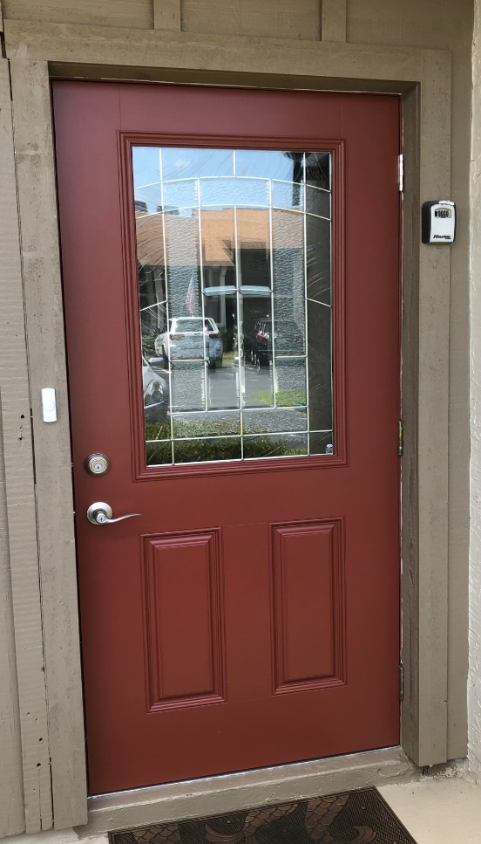  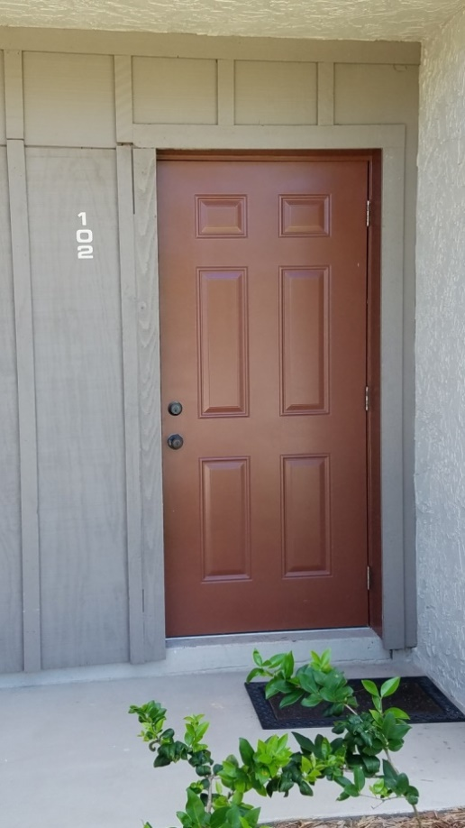

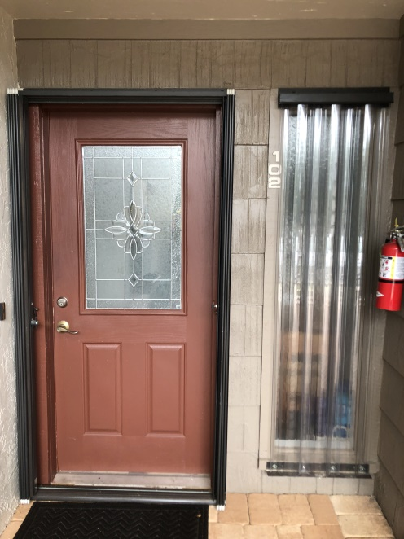 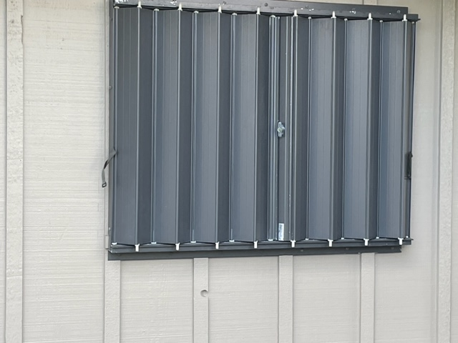

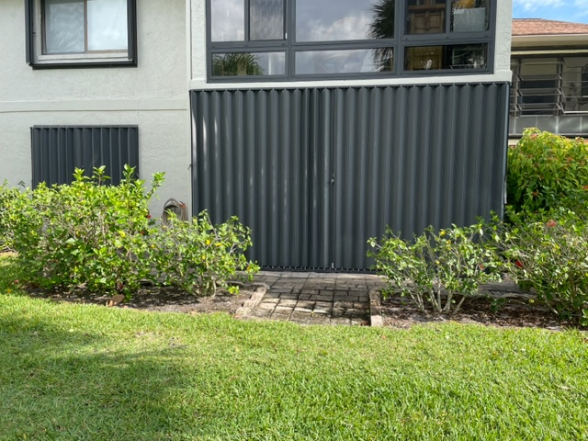 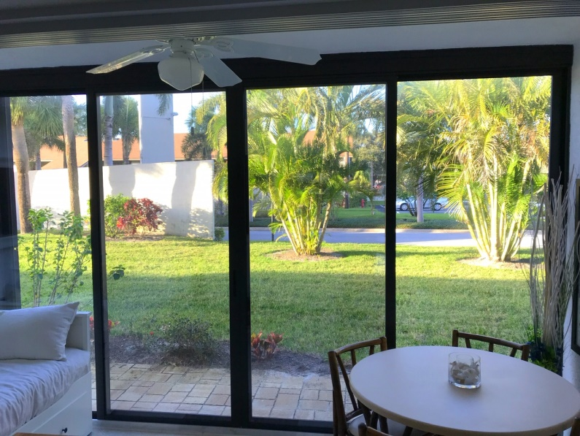

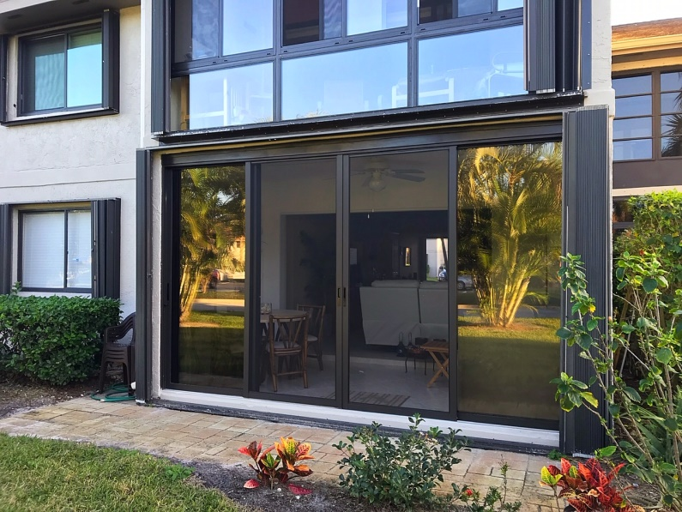 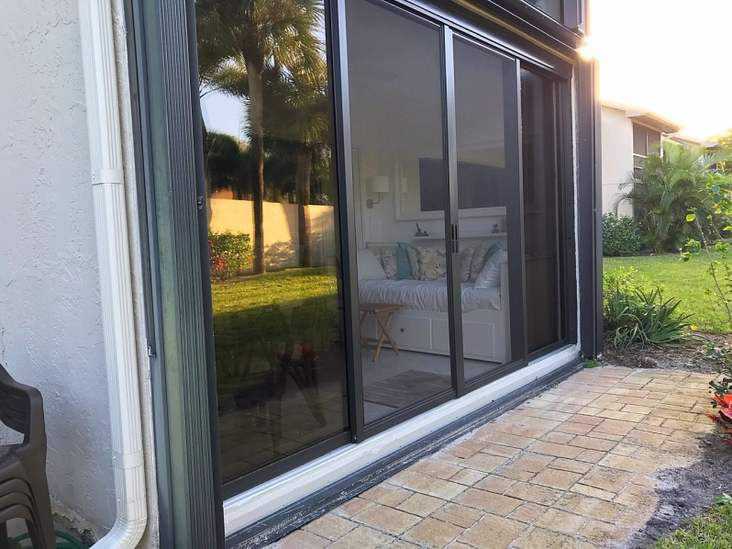

Sample Stickers



**RIVER CLUB ARCITECTURAL MODIFICATION/REPLACEMENT APPLICATION**

This form is to be used when owners wish to replace or install windows, doors, patio unit enclosures and/or shutters.

Please fill this form out for Board signature prior to installation.

Application Date: ______________

Building and Unit #: ______________

Owner Name: ______________________________

Modification Type:

Window Replacement: ____ Door Replacement: ____ Patio/Lanai: ____ Shutter Install: ____

Specifications: Replacement of windows, doors, hurricane shutters and lanai/patio glass must meet ~~both Martin County~~ ~~and~~ Miami-Dade County HVHZ hurricane impact requirements, whichever is more stringent. Meeting these requirements standards allows us to receive wind mitigation credits from the insurance companies as well as providing the maximum amount of protection for our buildings by code. ~~While Martin County building codes may be less stringent, the insurance companies are requiring us to meet Miami-Dade County impact resistance codes that include the large missile impact resistance level D for credit refund purposes.~~ If you do not know if the proposed door, window, shutter or lanai ~~unit~~ enclosure meets these codes, please contact your contractor or the unit manufacturer. During the mitigation inspection, you must have proof by permit and by the manufacturer having met the HVHZ impact code that would include ATSM E1996 Level D rating.

Licensed Contractor installing the unit: ___________________________________________

Door/Window/Patio Enclosure Manufacturer: ___________________________________________

Have you confirmed that this unit meets or exceeds the Impact specifications noted above (circle): Y / N

Please provide River Club with documentation for the unit file indicating the new windows, doors and/or shutters are compliant with the HVHZ codes listed above. ALL owner units must be in compliance in any one building for insurance mitigation credits to be applied to our association’s policy. Your individual insurance policy will also benefit in getting these credits.

Owner Signature: ________________________________________ Date: __________

Board Approval: ________________________________________ Date: __________

Last mod: 9/13/2023