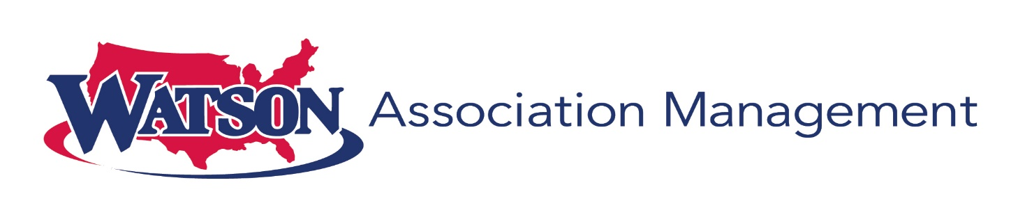
1648 SE Port St Lucie Blvd
Port St Lucie, Florida 34952
Tel: (772) 871-0004

We are excited that we will be managing your beautiful Community starting June 1, 2024. The Property Manager, Administrative Assistant and Regional Manager will be present on June 3rd between the hours of 9:00am – 1:00pm to assist with any questions or help with setting up payments.

Our Administrative Assistant will be onsite Monday-Friday from 9:00 am-1:00 pm

Ashley Buss, LCAM Ashleyb@watsonrealtycorp.com

Genesis Pyne, Admin Assistant Transitionc@watsonrealtycorp.com

Alicia Rodriguez, Regional Manager arodriguez@watsonrealtycorp.com

